**AQM- AIR QUALITY MONITORING**

**Phase 1: Problem Definition and Design Thinking**

In this part you will need to understand the problem statement and create a document on what have you understood and how will you proceed ahead with solving the problem. Please think on a design and present in form of a document.

**Project Definition:**

The project involves setting up IoT devices to measure air quality parameters and make the data publicly available for raising awareness about air quality and its impact on public health. The objective is to create a platform that provides real-time air quality information to the public. This project includes defining objectives, designing the IoT monitoring system, developing the data-sharing platform, and integrating them using IoT technology and Python.

**Design Thinking:**

1. **Project Objectives:** Define specific objectives such as real-time air quality monitoring, data sharing, public awareness, and health impact.
2. **IOT Devices Designs:** Plan the design and deployment of IoT devices (sensors) to measure air quality parameters.
3. **Data Sharing Platform:** Design a web-based platform to display real-time air quality data to the public.
4. **Integration Approach:** Determine how IoT devices will send data to the data-sharing platform.

**Project description:**

M any times we feel very weak while waking up from the bed even after getting a good sleep at night. This sometimes happens because of the poor air quality in the closed room at night.

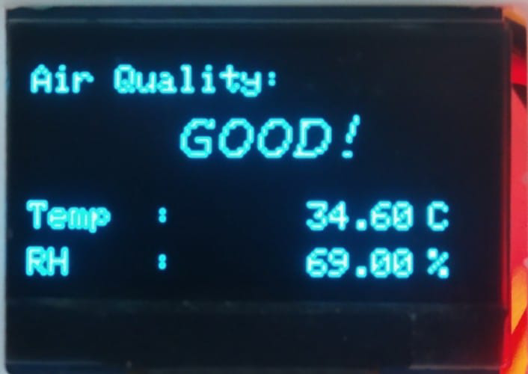

**Wiring:**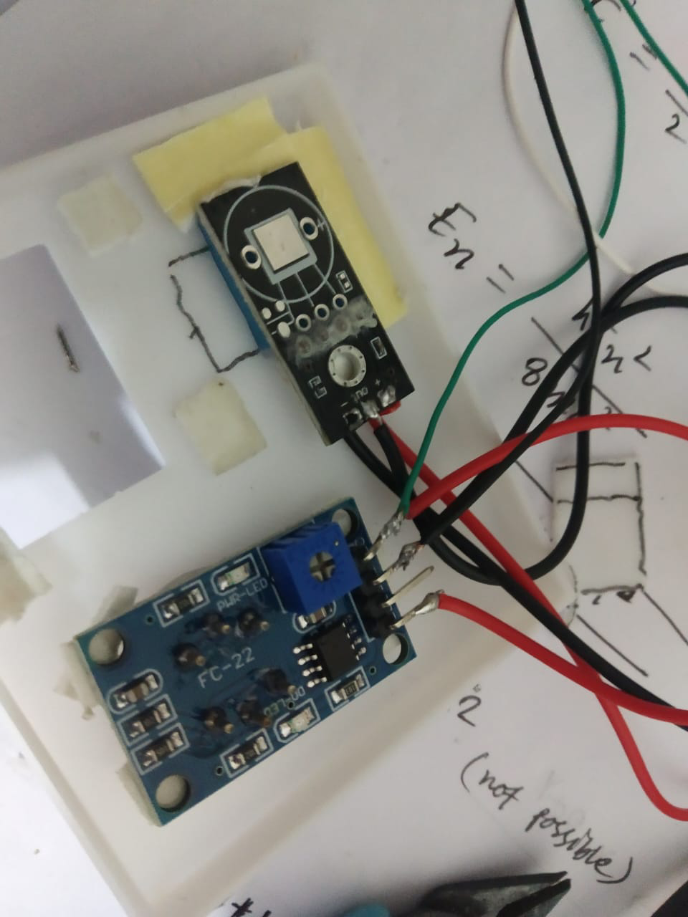

**Connect:**

* Arduino D2 to DHT11 out
* Arduino A0 to MQ135 Ao
* Arduino A5 to Oled SCL
* Arduino A4 to Oled SDA

**Required Components:**

1. MQ135 Gas sensor
2. Arduino Uno
3. Wi-Fi module ESP8266
4. 16X2 LCD
5. Breadboard
6. 10K potentiometer
7. 1K ohm resistors
8. 220 ohm resistor
9. Buzzer

**Coding**

In the coding part you will need to install some library to run the code

Adafruit_SSD1306.h

Adafruit_GFX.h

DHT.h

**INSTRUCTIONS:**

**Step 1: Download and Install Git**

1. Visit the official Git website: <https://git-scm.com/>

2. Download the appropriate version of Git for your operating system (Windows, macOS, or Linux).

3. Run the installer and follow the on-screen instructions to complete the installation.

4. Open a terminal or command prompt and verify the installation by typing git−−version.

**Step 2: Download and Install Visual Studio Code**

1. Go to the Visual Studio Code website: <https://code.visualstudio.com/>

2. Download the installer for your operating system (Windows, macOS, or Linux).

3. Run the installer and follow the installation prompts.

4. Launch Visual Studio Code.

**Step 3: Create a GitHub Account**

1. Open a web browser and go to <https://github.com/>

2. Click on the "Sign up" button.

3. Follow the registration process, providing your username, email address, and password.

4. Complete the verification process if prompted.

**Step 4: Create a GitHub Repository**

1. Log in to your GitHub account.

2. Click on your profile icon in the upper right corner and select "Your repositories" from the dropdown menu.

3. On the "Repositories" page, click the green "New" button.

4. Fill in the required information for your new repository, including the repository name, description, visibility, and other settings.

5. Optionally, you can choose to initialize the repository with a README file or add a .gitignore file for your specific project.

6. Click the green "Create repository" button to create your GitHub repository.

**Step 5: Create a Local Folder**

1. Minimize any open windows on your computer to see your desktop.

2. Right-click on an empty area of your desktop.

3. Hover over "New" in the context menu.

4. Click on "Folder" to create a new folder.

5. Give your folder a meaningful name, like "MyProject."

**Step 6: Open the Folder in Visual Studio Code**

1. Launch Visual Studio Code.

2. Click on "File" in the top-left corner.

3. Select "Open Folder" from the dropdown menu.

4. Browse to your desktop and select the folder you created in Step 5 (e.g., "MyProject").

5. Click the "Open" button to open the folder in Visual Studio Code.

**Step 7: Clone Your GitHub Repository**

1. In Visual Studio Code, open the integrated terminal by clicking on "View" in the top menu and selecting "Terminal" or using the keyboard shortcut (**Ctrl+** on Windows/Linux or **Cmd+** on macOS).

2. Use the **git clone** command to clone your GitHub repository by pasting the HTTPS URL of your repository. Replace **repository_url** with the actual URL.

   git clone <repository_url>

3. Navigate to the newly created repository folder using the cd command:

   cd <repository_name>

**Step 8: Check Git Status**

1. To check the status of your local repository, enter the following command:

   git status

**Step 9: Modify the README File**

1. Open the README file in your repository folder using Visual Studio Code.

2. Make the desired modifications to the README file.

**Step 10: Check Git Status Again**

1. Return to the terminal in Visual Studio Code.

2. Use the gitstatus command again to see the changes you made:

   git status

**Step 11: Add Modifications to Staging Area**

1. To stage your changes for a commit, use the gitadd command:

   git add README.md

**Step 12: Commit Your Changes**

1. Commit your staged changes with a descriptive message:

   git commit -m "Updated README file"

**Step 13: Push Changes to GitHub**

1. Push your committed changes to your GitHub repository:

   git push

**Step 14: Create a New Branch**

1. To create a new branch, use the gitbranch command followed by the desired branch name:

   git branch branch_name

**Step 15: Switch to the New Branch**

1. To switch to the newly created branch, use the gitcheckout command:

   git checkout branch_name

**Step 16: Check Your Current Branch**

1. To confirm the branch you're currently working on, use the gitbranch command:

  git branch

**Report:**

All the above instructions are installed and executed successfully.

**Project by:**

* **Name:** T. ASWIN
* **Dept:** ECE III YEAR
* **Reg No:** 420121106008
* **College code:** 4201
* **Group:** IBM-Group 2